HTML Assignment 3 - World Tour (Using Divs) - /20

(part of the Client Side Scripting Credit)

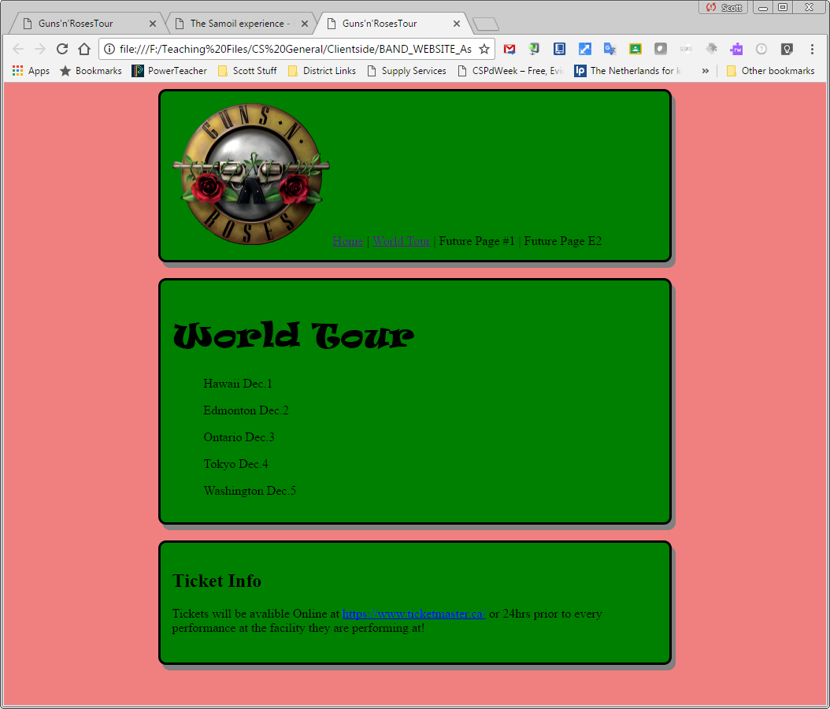

You are going to add a second page to your band website. This page will advertise the same band’s upcoming world tour.

* Div tags
* Header based styles for Divs

For the final 10%, you will also need to:

* Use header styles (or an external style sheet) for most of your styles but using inline styles to style individual paragraphs, etc.
* Note: You may not have learned this YET. We will teach you this soon or you can [check it out here](https://www.w3schools.com/css/css_howto.asp).

**File Setup:**

* Save a new file as worldtour.html into your BAND_WEBSITE folder

**Styles for the Assignment**

If you are aiming for 100%, you will need to use an external style sheet. You can do that now or later. If you are waiting until later, just put the style tags at the top of the HTML file. NOTE: You may not have learned this YET. We will teach you this soon or you can [check it out here](https://www.w3schools.com/css/css_howto.asp).

Text Styles - **/3**

* Body Background Color or PICTURE - If using a color, use the same color scheme as on your band_index page. Want to know now to use a background picture? Look on w3schools… CSS… CSS Backgrounds.
* Heading and paragraph color - Use the same color scheme as on your home page
* Heading font - choose a font face
* Paragraph font - choose a different font face

Div Styles - all your divs can use the same style on this assignment **- /3**

* 80% width
* Background colors
* Thick, colored border (not black)
* Padding (you decide on the amount)

**ProTip:** Want to center your div across the page?

margin-left: auto;

margin-right: auto;

**The rest of the HTML**

1. In the <head> section add an appropriate meta-title. **- /1**

2. In the <body> section set up 3 empty divs and then add the code to each as described below.  **- /1**

3. First Div - Create a Navigation Bar **- /2**

* Place your band’s logo inside this div.
* Beside the logo use simple links to create a Navigation bar that links between the two pages of your band website. Also add placeholders for future pages. A simple but effective layout is the following:

Home | World Tour | Future Page #1 | Future Page E2

* + Links reminder: <a href=”band_index.html”>Home</a>
  + Note: Assuming the pages are in the same folder, the link should just be “___.html” and not “F:/ComputerScienceWork… ___.html” as Mr. Couprie does not have the same F: drive as you do.

Now make the Navigation Bar Div look better:

* Adjust the size of the logo if necessary
* Optional: Add a vertical-align style inside your image tag so the text beside it is centered vertically alongside the picture:
  + <img src=”somephoto.jpg” style=”vertical-align: middle; width=”50%”;>

**ProTip:** To create an empty space between your divs for a better look

add a paragraph <p> between your divs

OR add *padding-bottom* style to your divs

4. Second Div - Main content: **- /2**

* Add a heading: World Tour Dates
* A unordered list using <ul> & <li> with 5 dates and cities listed (these can be made up)

5. Third Div - Ticket Info **- /2**

* A heading: Ticket Information
* Add some realistic info in a <p> or <ul> or in whatever manner you choose.
* If you want, add a link to TicketMaster.

All of the above is worth 70%.

Add as many of the following as you can to improve this mark:

**Next 10% - /2**

To your Div styles, add the following:

* Rounded corners - <http://www.w3schools.com/css/tryit.asp?filename=trycss3_border-radius>
* One more setting of your choice such as a linear-gradient or something else.

**Next 10 - /2**

* Copy your Navigation Bar Div into your assignment 1. This will also require you to add some styles or link to the same external .css file if you are going that route.

**Next 10% - /2**

* Update the first page so that it uses the same divs and styles to give your entire site a specific look.
* Recommended but not required: Move all your styles into an external CSS file saved as as bandStyles.css. Then get both pages to point to that CSS file so all styles are consistent moving forward.